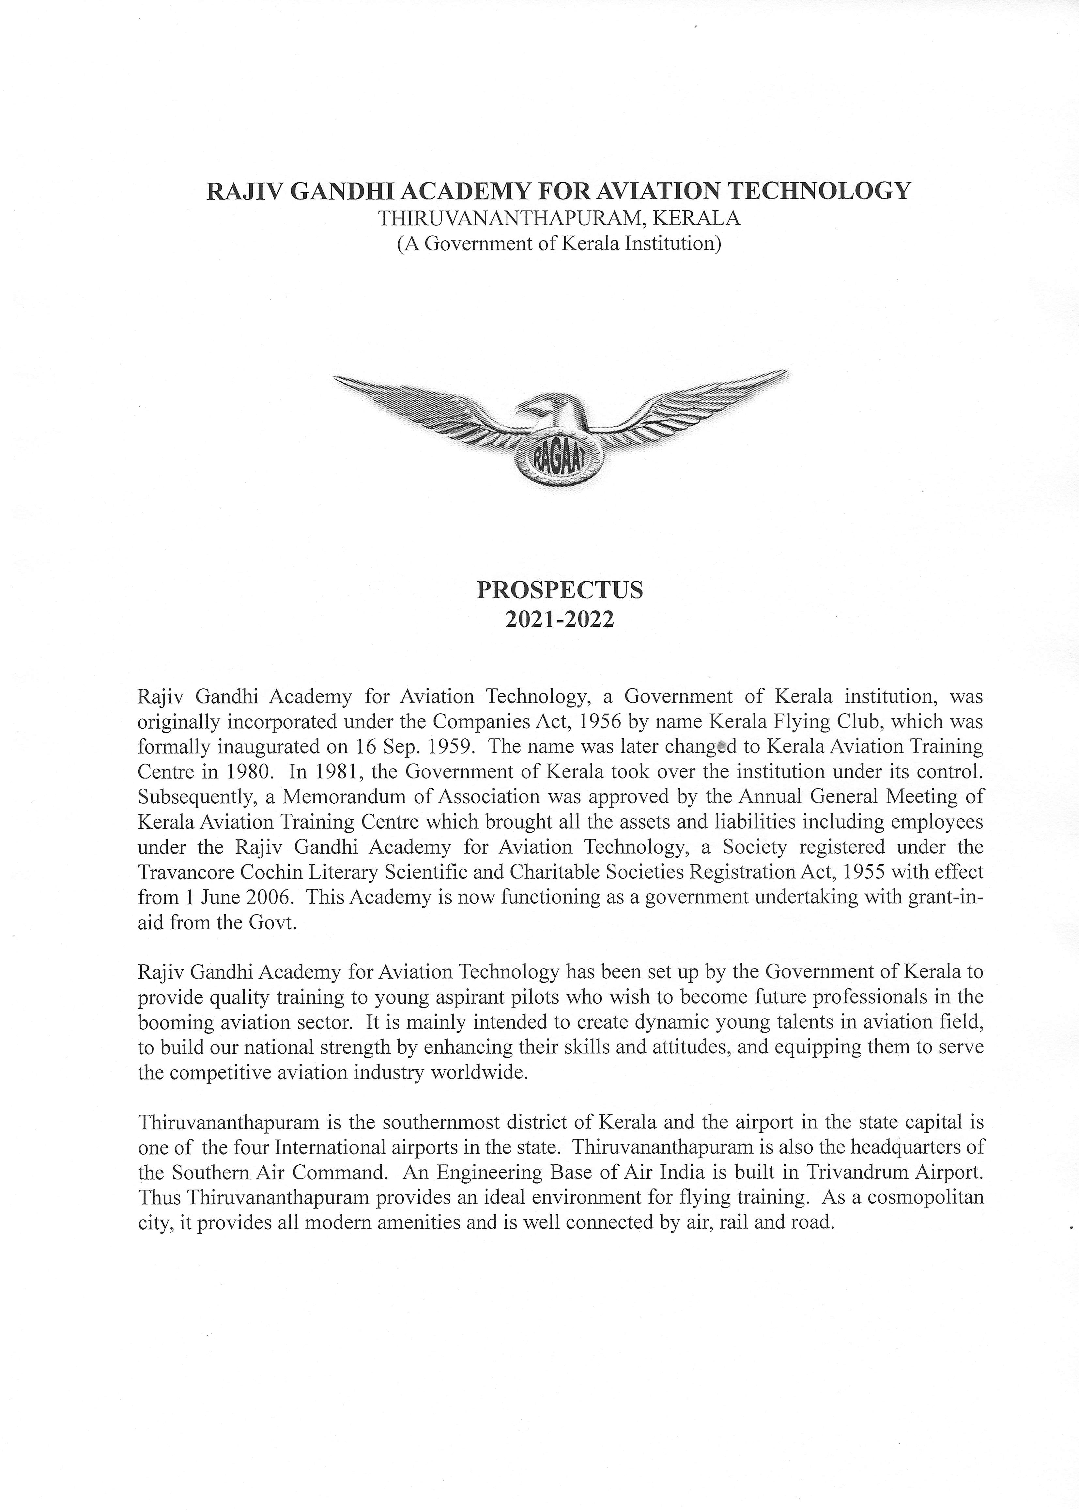

RAJIV GANDHI ACADEMY FOR AVIATION TECHNOLOGY,
THIRUVANANTHAPURAM, KERALA.

(A Government of Kerala Institution)

APPLICATION FORM

2021-2022

For Office Use Only:

Page 1 of 5

RAJIV GANDHI ACADEMY FOR AVIATION TECHNOLOGY

International Airport,
Thiruvananthapuram, Kerala- 695 007

Recent passport size Colour Photo

 | APPLICATION FOR FLYING TRAINING
1. | Name in Full (Block Letters): | ……………………………………………………
2. | Male/Female: | ……………………………………………………
3. | Date and Place of Birth: | …………………………………………………….
4. | Educational Qualification: | …………………………………………………….
5. | Nationality: | ……………………………………….....................
6. | State of Domicile: | ……………………………………….....................
7. | Present Occupation: | ……………………………………………………..
8. | Name of Father/Guardian: | ……………………………………………………..
 |  | Tele:………………………………………………

Mobile:………..………………………………….

Email:…………………………………………….

Page 2 of 5

9. Address (Permanent): |  | ……………………………………………………
 |  | ……………………………………………………
 |  | ……………………………………………………
 |  | State:……………………………………………..
 |  | Pin………………………………………………...................
10. | Address (Present): | …………………………………………………….
 |  | …………………………………………………….
 |  | …………………………………………………….
 |  | State:……………………………………………..
 |  | Pin…………………………………………………
11. | Email of the applicant: | …………………………………………………….
12. | Address of the Police Station
 | closest to the present address | ……………………………………………………..
 |  | ………………………………………..……………..
 |  | ………………………………………..……………..
13. | Course selected for training:
 |  | ……………………………………………………….

Page 3 of 5

- Full particulars of pervious flying if any:

  - Date of commencement of flying…………………………………………….…………..

(b) Details Licence obtained, if any |  | …………………………………………………..
(c) Licence No & Validity | ……………………………………………………..
(d) Type of aircraft flown | ……………………………………………………..
 | Dual | Solo

(e) Total hours flown:Day………………….. | …………..………….
Night……………....... | ……………..……….
Total………………… | ………….………….

15. Particulars of DGCA exams passed, if any,

for PPL/CPL………………………………………………………………..…………….

………………………………………………………………………………..…………….

16. Whether SC/ST ………………………………………………………

17. Demand Draft No:…………………………. Issue Bank:…..…………………………..

Issue Branch………………………………. Issue Date…………………………..…….

Declaration

I hereby undertake to abide by the rules and regulations of Rajiv Gandhi Academy for Aviation Technology, Thiruvananthapuram. I also declare that the Rajiv Gandhi Academy for Aviation Technology, Thiruvananthapuram, will not be held responsible for any accident/incident happening to me on account of my flying training, etc. I shall execute separate indemnity bond before commencement of flying training. I further state that the information given above is true to the best of my knowledge and belief.

Date: Signature of the applicant

Date: Counter Signature of parent/guardian

Mobile No:……………………………...

Page 4 of 5

Instructions:

- Prospectus can be downloaded from the Academy’s website. (www.rajivgandhiacademyforaviationtechnology.org)

- Candidates should download the application form from the web site and should submit completed application form along with the Demand Draft as per notification in favour of the " Executive Vice Chairman, Rajiv Gandhi Academy for Aviation Technology, Thiruvananthapuram" payable at Thiruvananthapuram.
Applications received without the Demand Draft will not be considered.

- Enclose two recent passport size photographs of the candidate along with the completed application form.

- The Name and Date of Birth of the candidate are to be entered on the reverse of the demand draft and enclosed photographs.

- Incomplete applications or applications received after the last date will be rejected.

- Attested copies of the following documents to be attached with the application form(originals to be produced at the time of interview):

  - Proof of date of birth

  - Class X pass certificate and mark sheet

  - Class XII pass certificate and mark sheet

  - Proof of SC/ST, (where applicable)

  - Certificate and mark sheet of additional qualifications, if any.

- Candidates who are awaiting the XII result are also eligible to apply for the course. They have to produce the XII pass certificate and mark sheet at the time of interview.

- If any information given above is found to be incorrect at a later stage, the candidate’s flying training may be terminated and fees paid (if any) will not be refunded. In addition, legal action may be initiated against the candidate.

Page 5 of 5

